junaid01@@@$$$

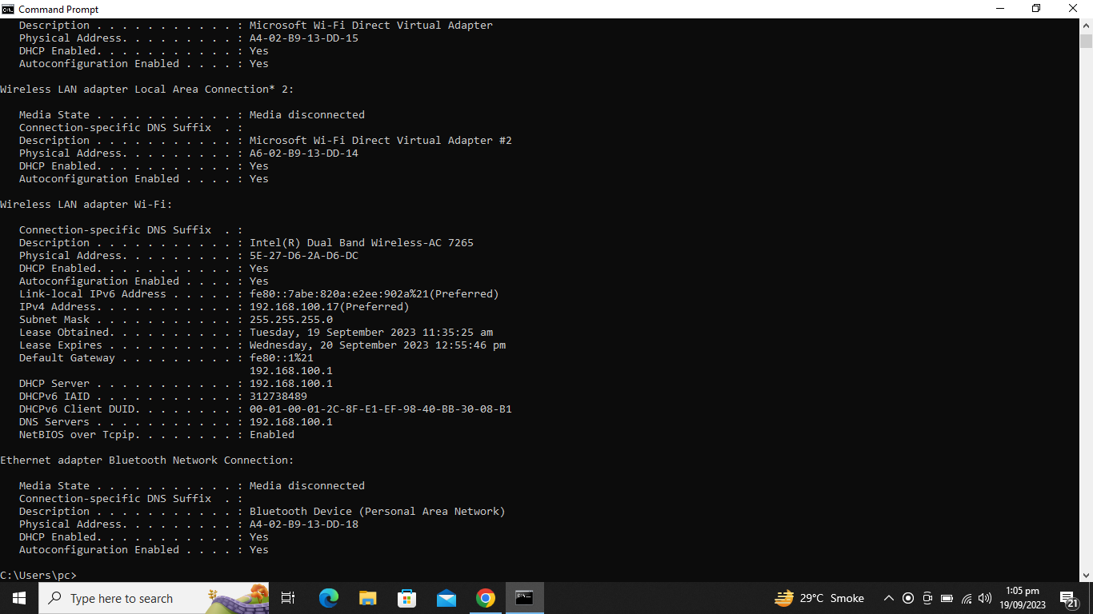

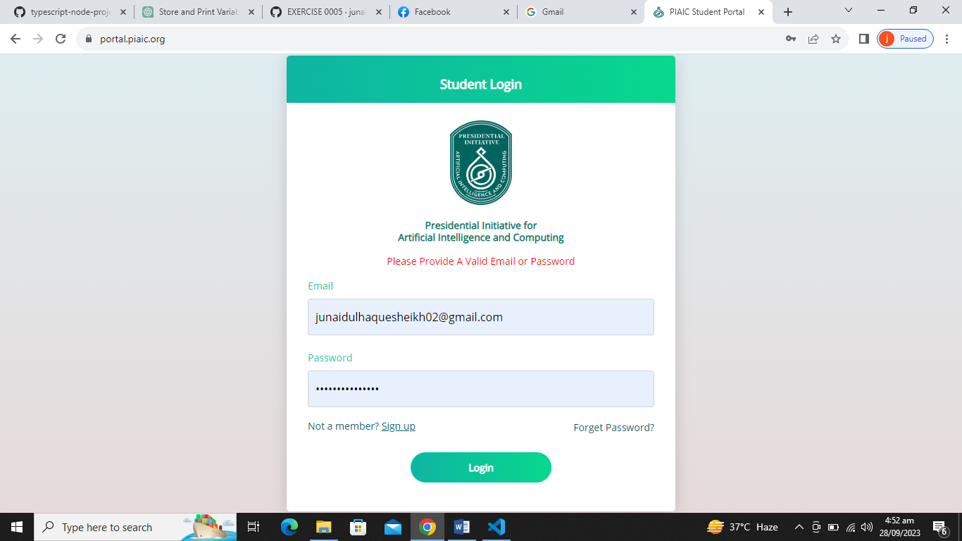

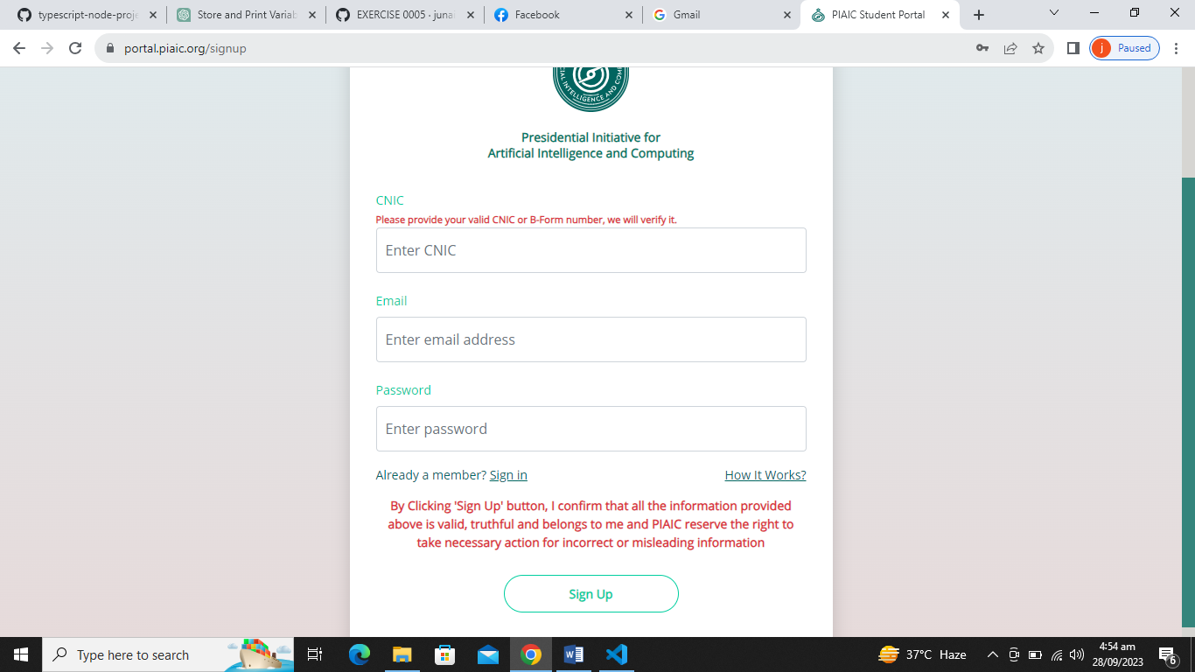

CONVERT PYTHON CODE INTO TYPESCRIPT CODE

CONVERT PYTHON CODE INTO JAVASCRIPT CODE

npm install –g typescript@latest

npm install your-package-name

tsc --init

tsc

node –v

npm –v

npm i inquirer

npm install inquirer

tsc –v

npm install –g ts-node

tsc app.ts

app.ts

node.js

node app.ts

ts-node app.ts

node –v

npm install

npm install -g typescript

tsc

tsc --init

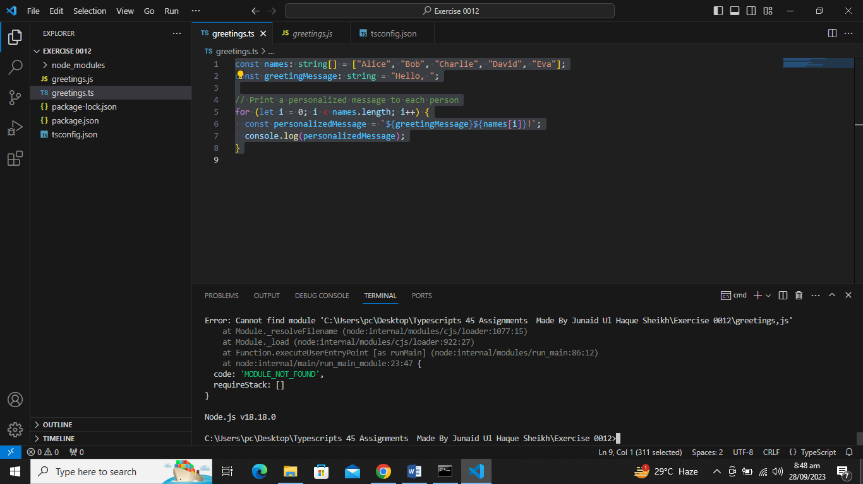

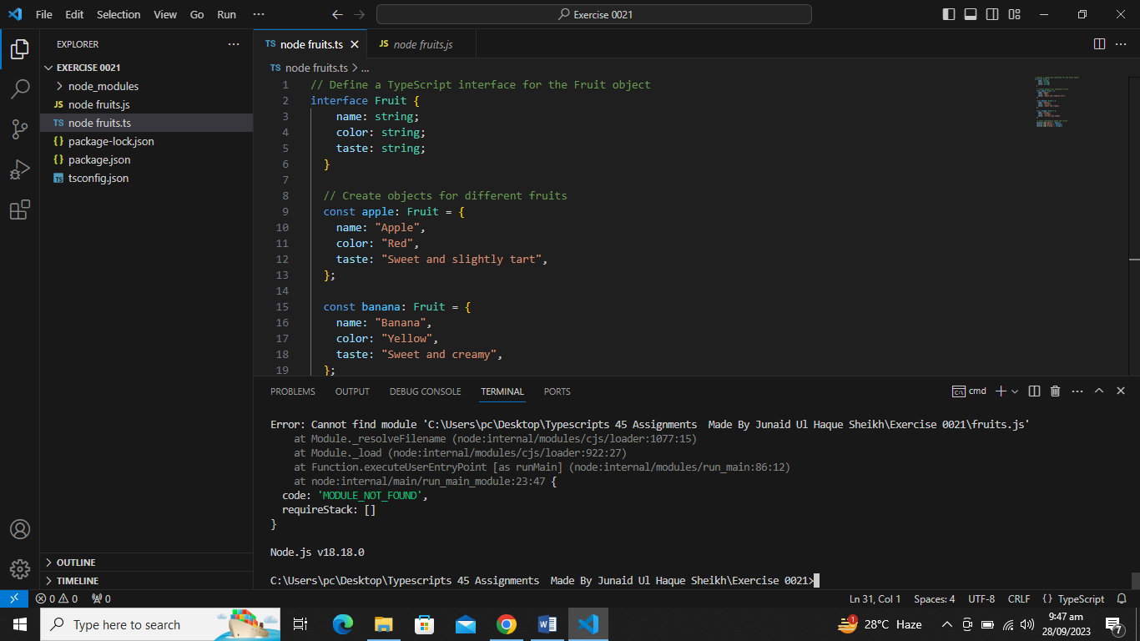

node favorite_number.js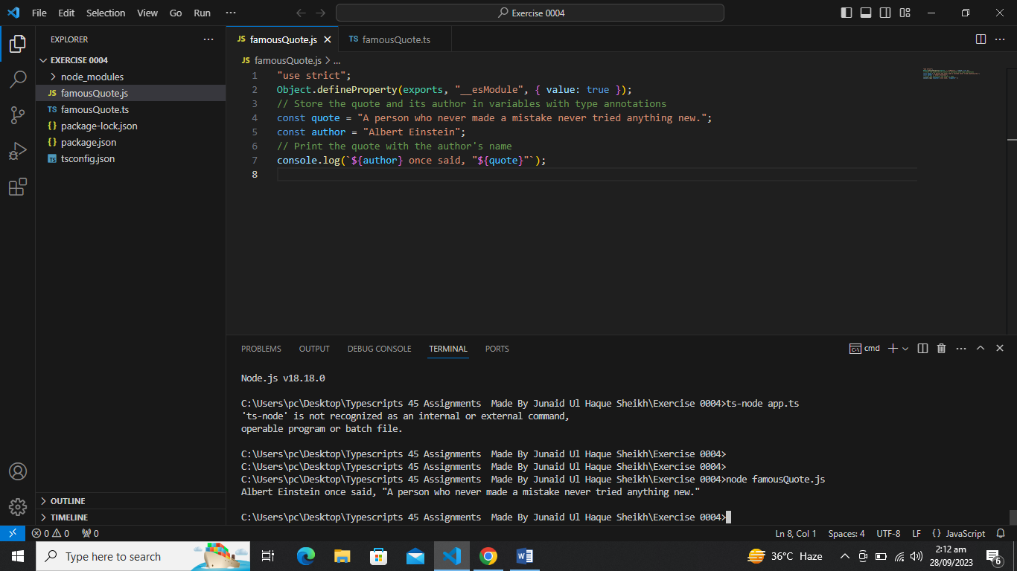

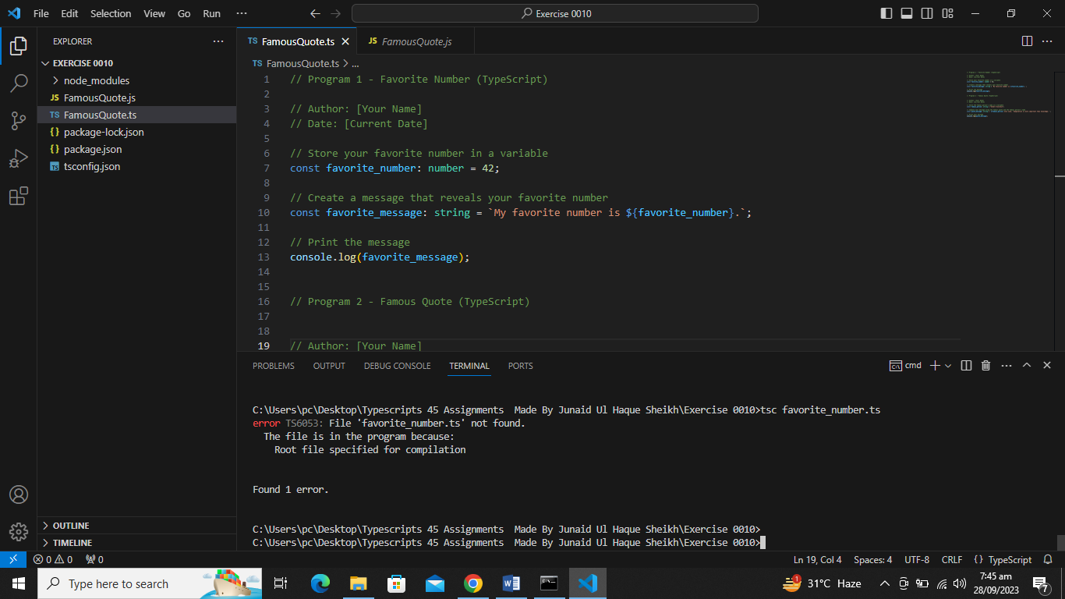

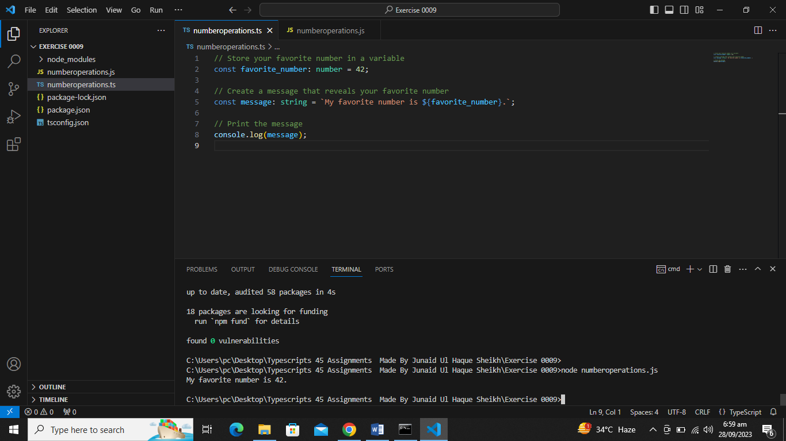

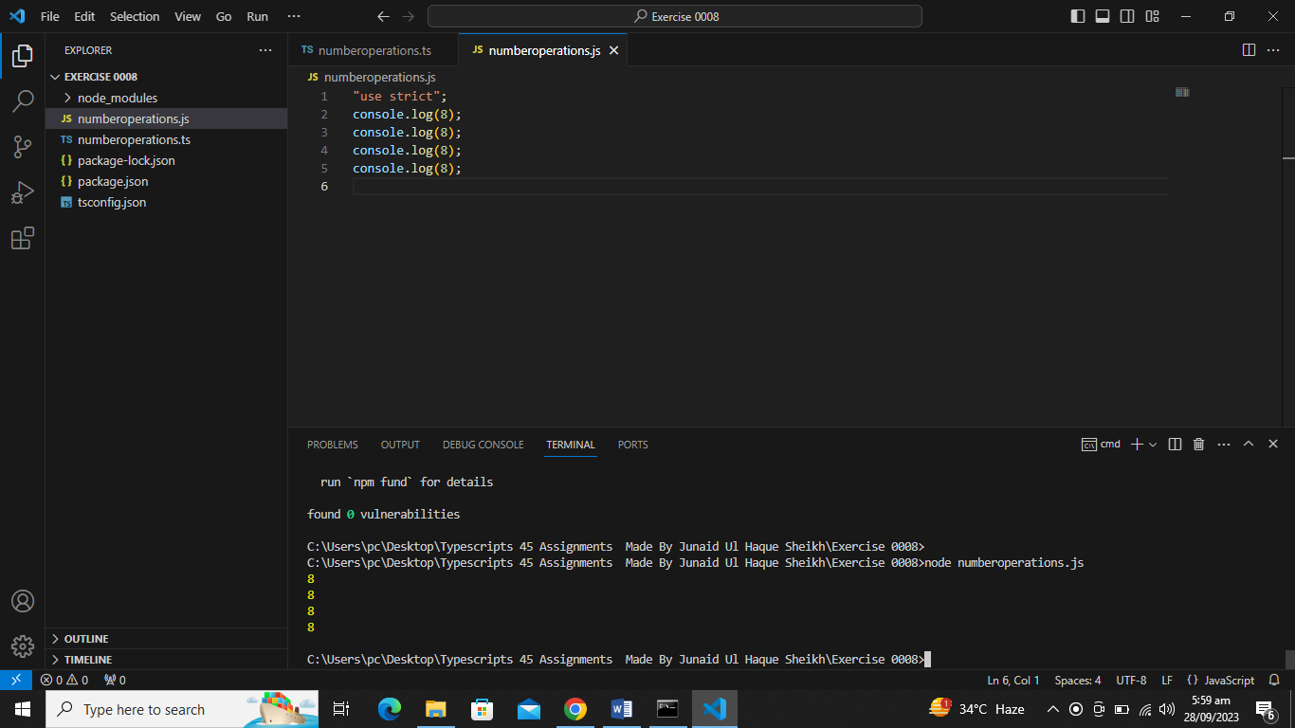

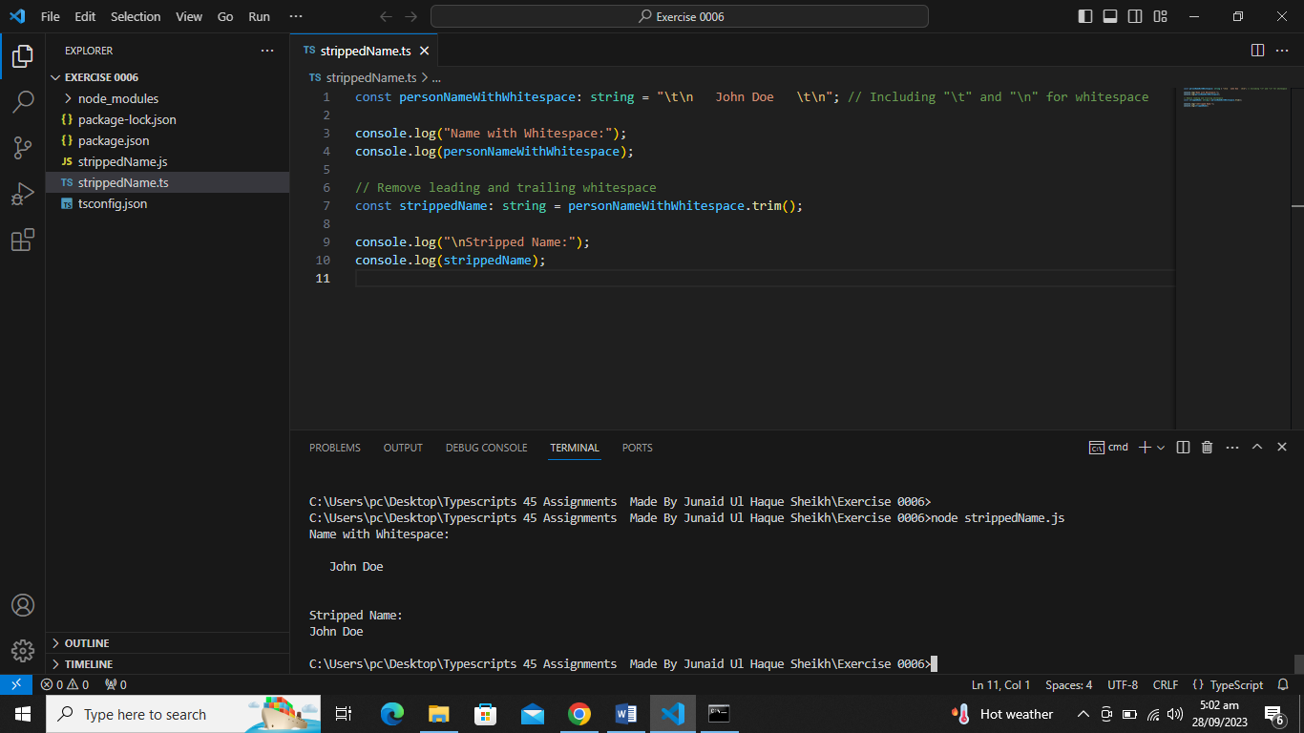

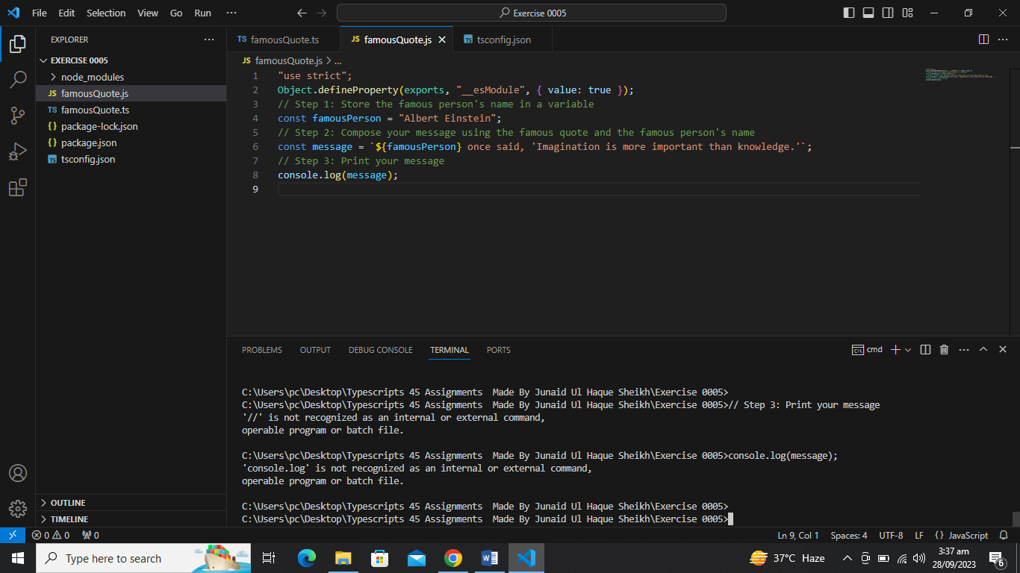

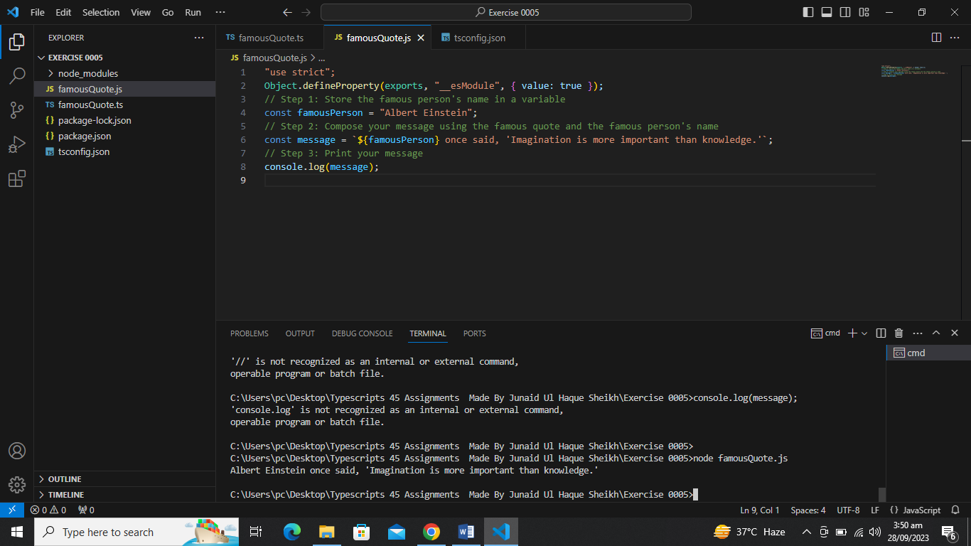

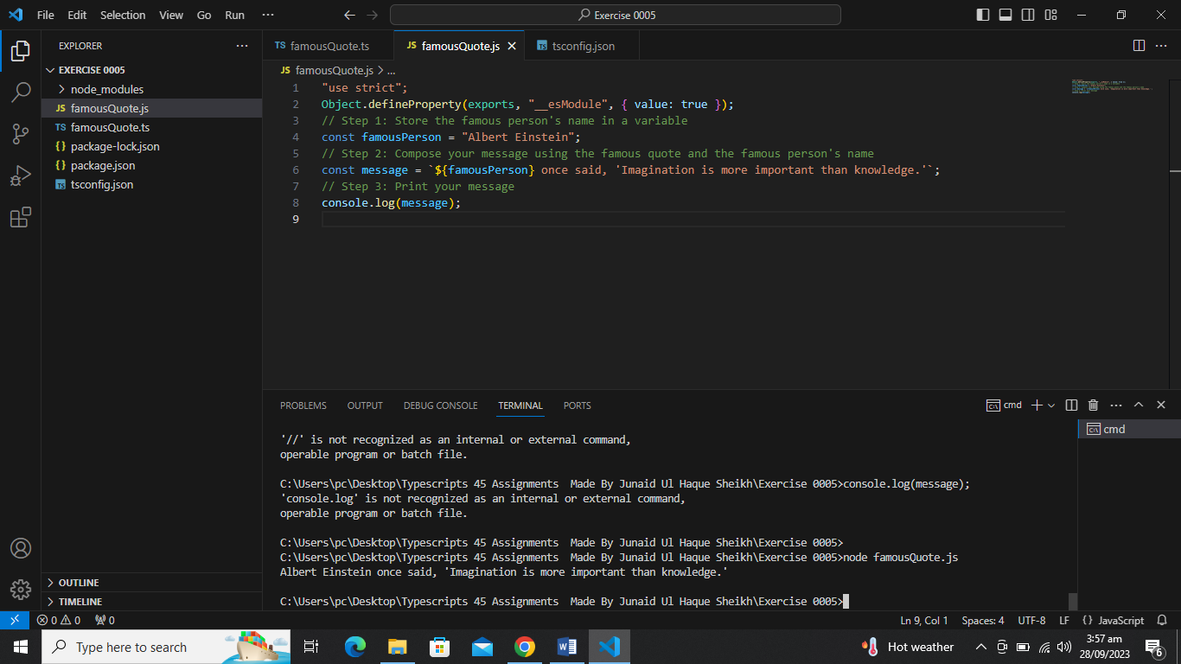

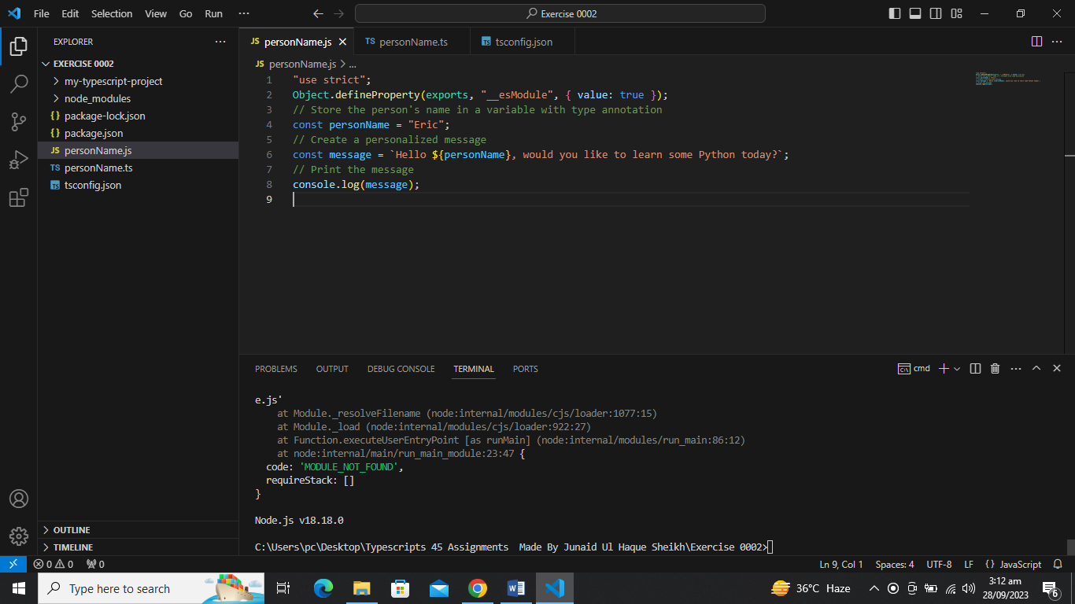

***EXERCISE # 0002***

[***https://github.com/junaidsheikh02/45-Assignments-Typescripts-Only/commit/ebbe95e76713f0986d152c2cce4a5fb39a5dbd40***](https://github.com/junaidsheikh02/45-Assignments-Typescripts-Only/commit/ebbe95e76713f0986d152c2cce4a5fb39a5dbd40)

***EXERCISE # 0003:***

[***https://github.com/junaidsheikh02/45-Assignments-Typescripts-Only/commit/0507646790a8ae8cda9bc9bbf7b579c2bcb646a5***](https://github.com/junaidsheikh02/45-Assignments-Typescripts-Only/commit/0507646790a8ae8cda9bc9bbf7b579c2bcb646a5)

***EXERCISE # 0004:***

[***https://github.com/junaidsheikh02/45-Assignments-Typescripts-Only/commit/fe55e2421398e63e2801be10170fc14ec8d59740Only/commit/0507646790a8ae8cda9bc9bbf7b579c2bcb646a5***](https://github.com/junaidsheikh02/45-Assignments-Typescripts-Only/commit/0507646790a8ae8cda9bc9bbf7b579c2bcb646a5)

***EXERCISE # 0005:***

***https://github.com/junaidsheikh02/45-Assignments-Typescripts-Only/commit/659d1c643d28ecb69291dbce626c4ad047ac11e4***

***sEXERCISE # 0006***

[***https://github.com/junaidsheikh02/45-Assignments-Typescripts-Only/commit/18c34a275815b854423f074498fa3256031fd991***](https://github.com/junaidsheikh02/45-Assignments-Typescripts-Only/commit/18c34a275815b854423f074498fa3256031fd991)

***EXERCISE # 0007***

[***https://github.com/junaidsheikh02/45-Assignments-Typescripts-Only/commit/0b0f5d95c33c86acafa29a80f2cb0b175bb2d159***](https://github.com/junaidsheikh02/45-Assignments-Typescripts-Only/commit/0b0f5d95c33c86acafa29a80f2cb0b175bb2d159)

***EXERCISE # 0008***

[***https://github.com/junaidsheikh02/45-Assignments-Typescripts-Only/commit/a2aa8b36a41553dd4733344dfc5ae59cb4e4fdb9***](https://github.com/junaidsheikh02/45-Assignments-Typescripts-Only/commit/a2aa8b36a41553dd4733344dfc5ae59cb4e4fdb9)

***EXERCISE # 0009***

[***https://github.com/junaidsheikh02/45-Assignments-Typescripts-Only/commit/bb14d39c57094d7268529c834908637ea4e01fc9***](https://github.com/junaidsheikh02/45-Assignments-Typescripts-Only/commit/bb14d39c57094d7268529c834908637ea4e01fc9)

***EXERCISE # 0010***

[***https://github.com/junaidsheikh02/45-Assignments-Typescripts-Only/commit/aa1b2be0c2f5c23010daa80d5771a844f2105a40***](https://github.com/junaidsheikh02/45-Assignments-Typescripts-Only/commit/aa1b2be0c2f5c23010daa80d5771a844f2105a40)

***EXERCISE # 0011***

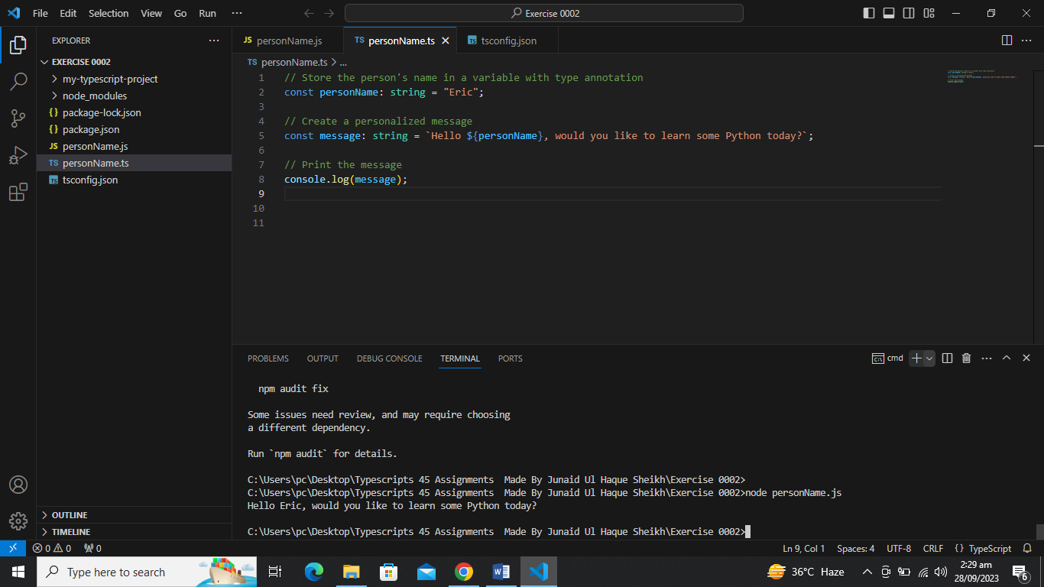

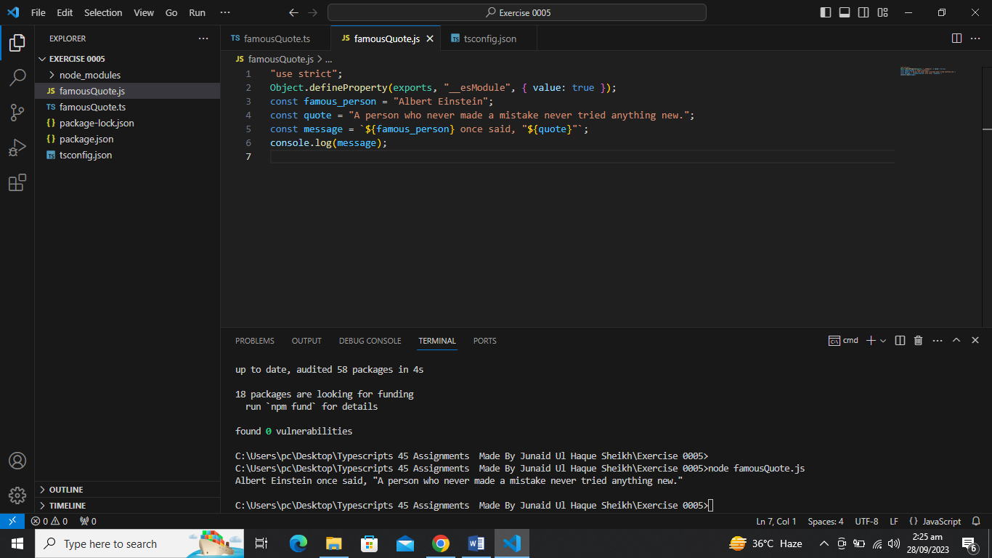

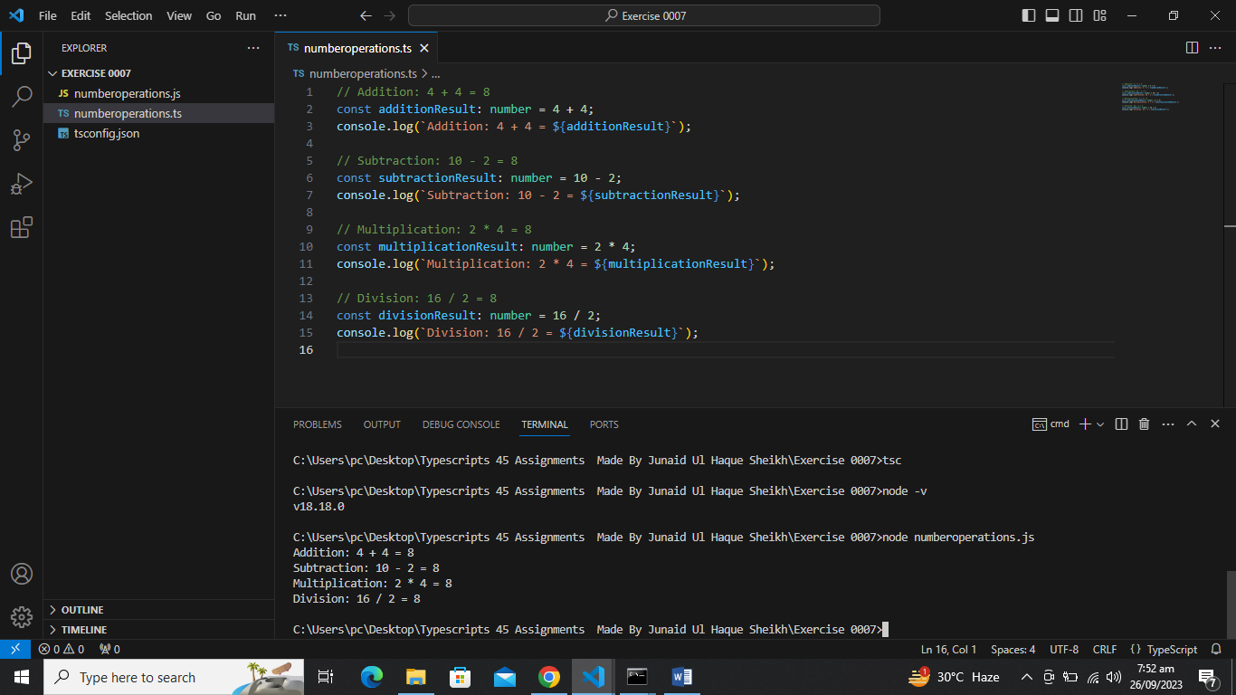

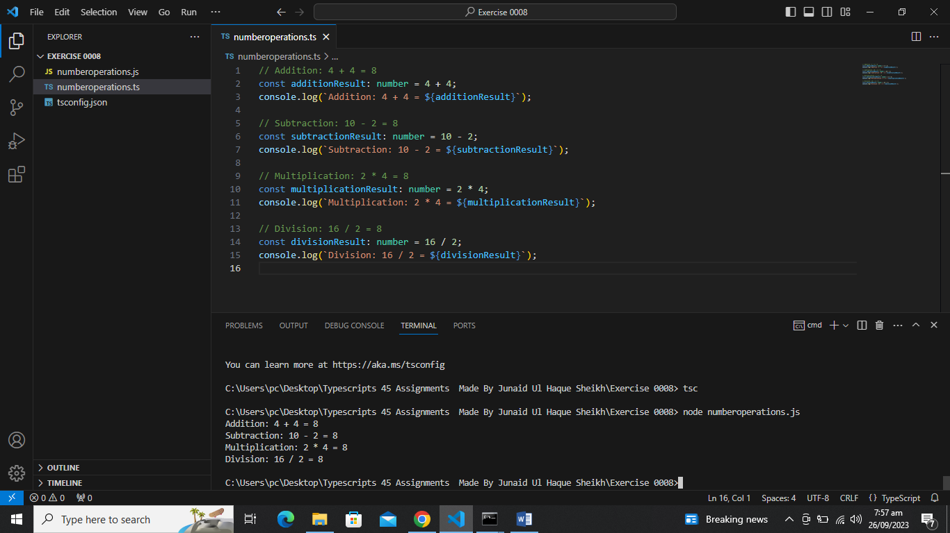

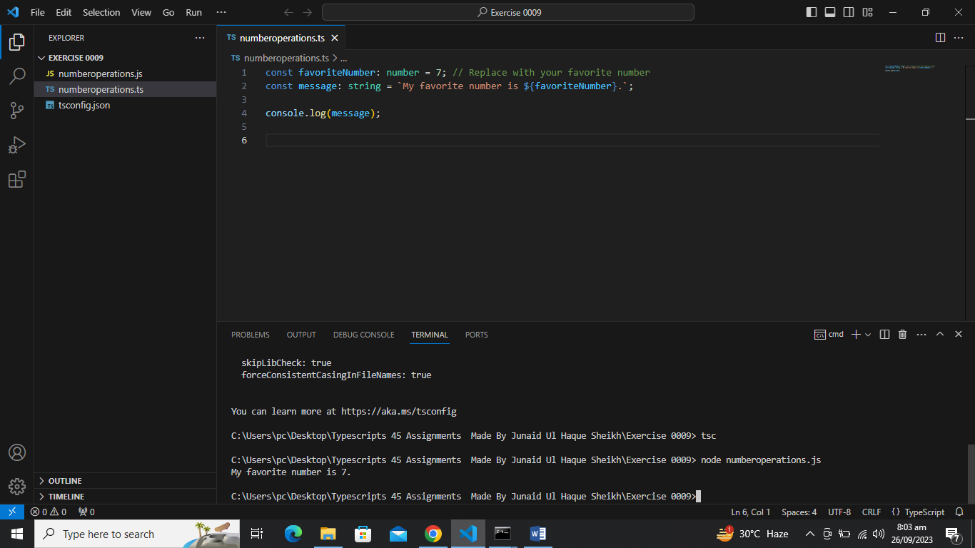

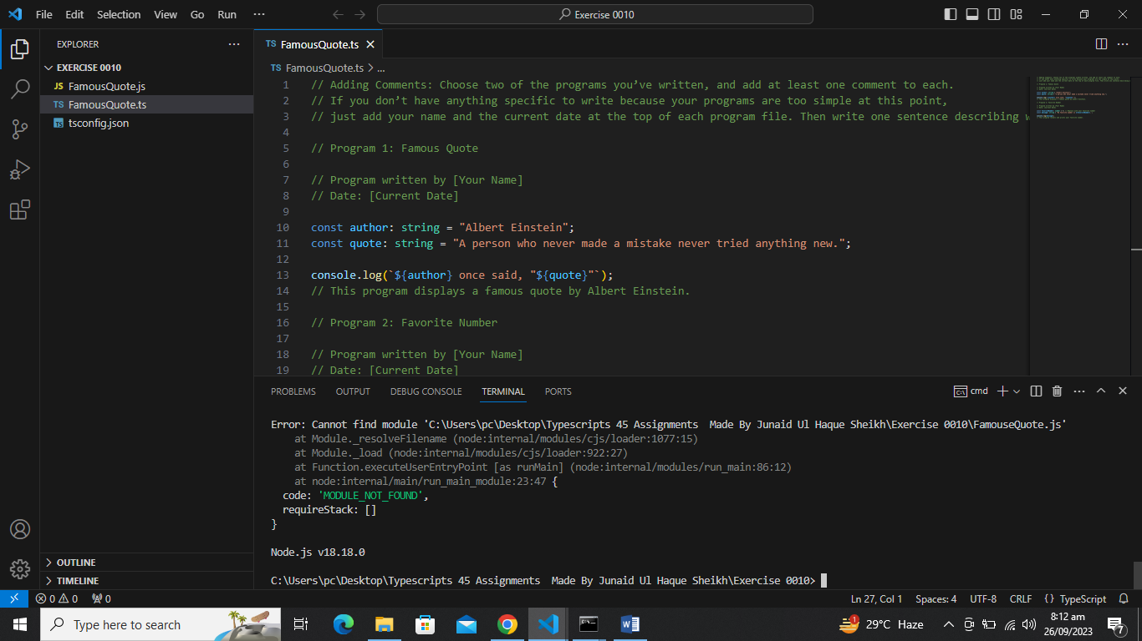

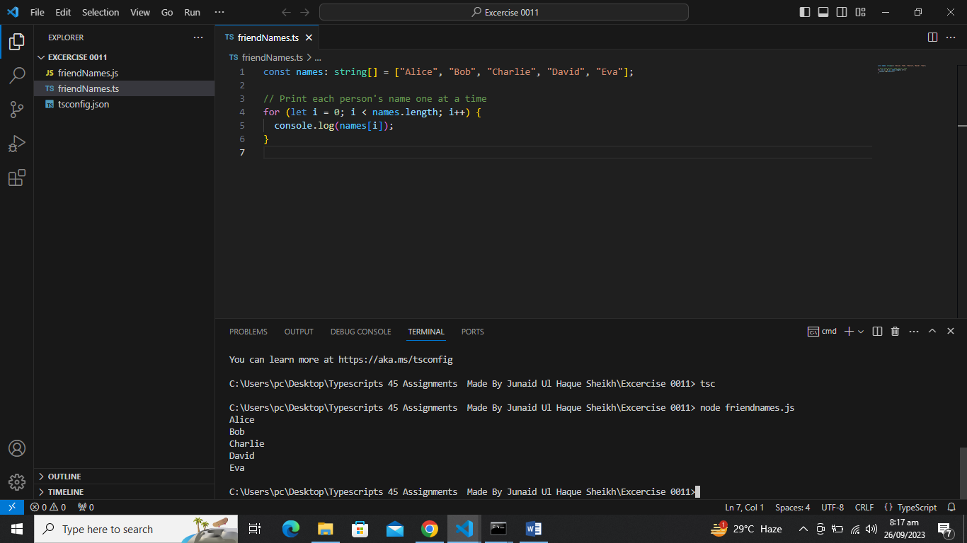

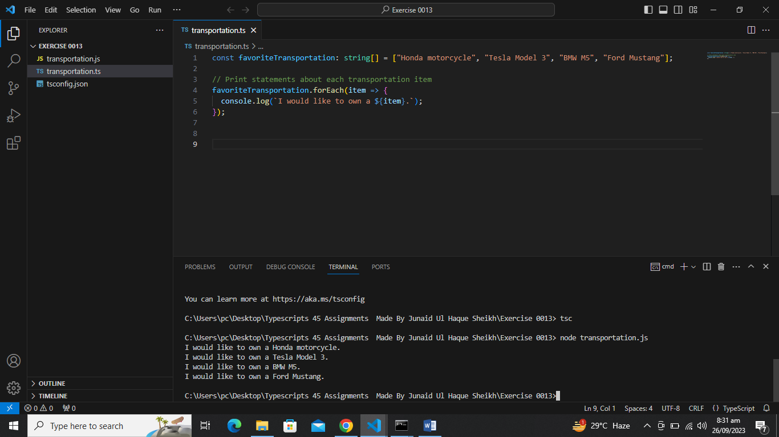

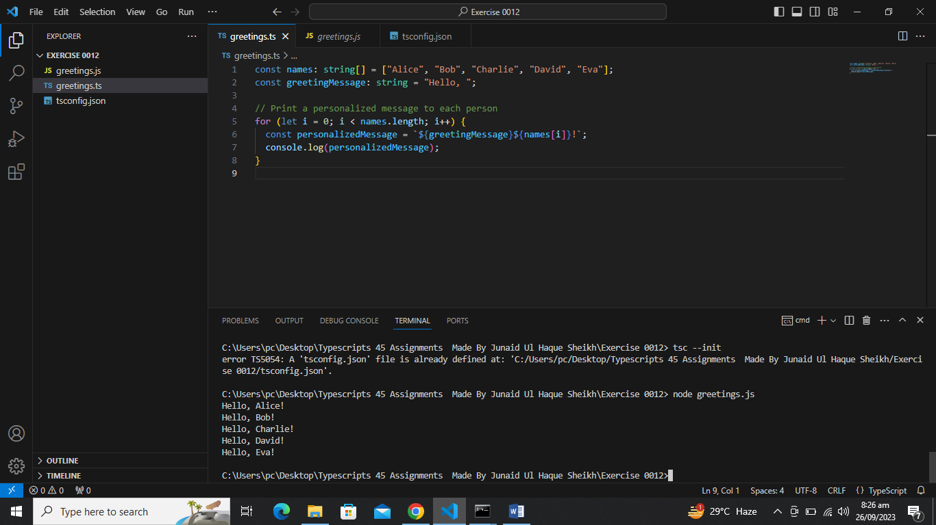

s

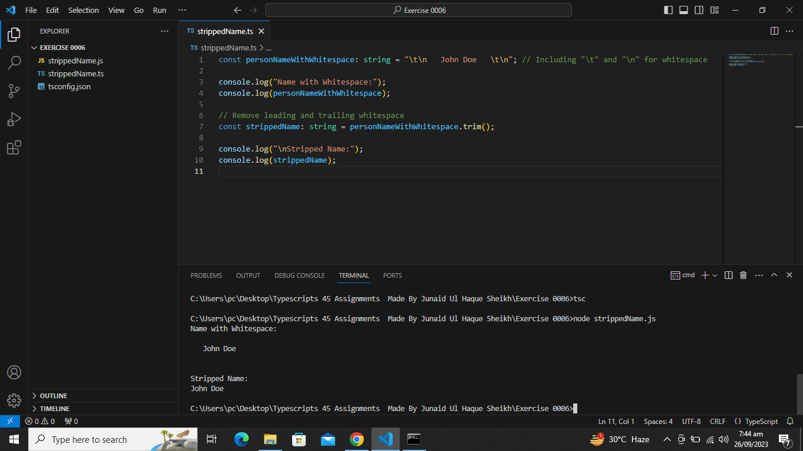

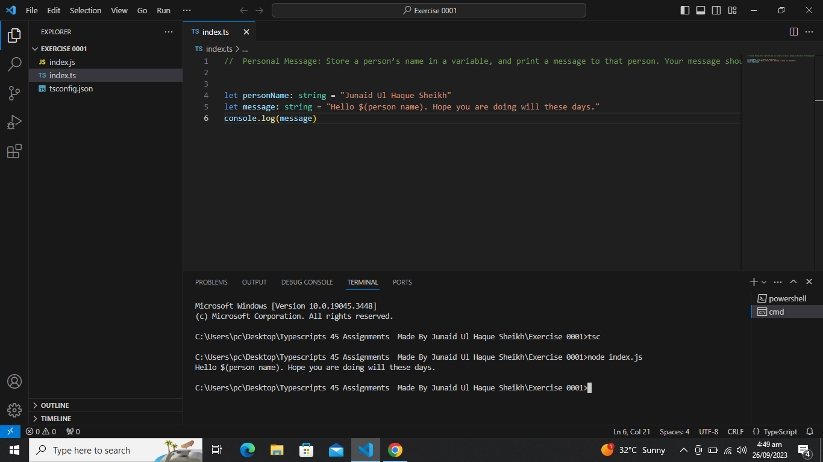

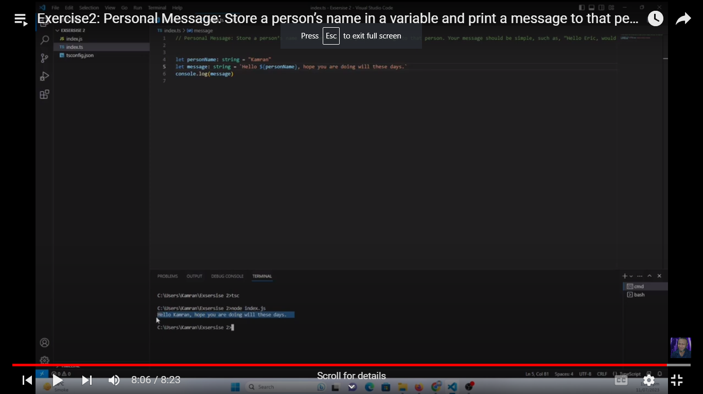

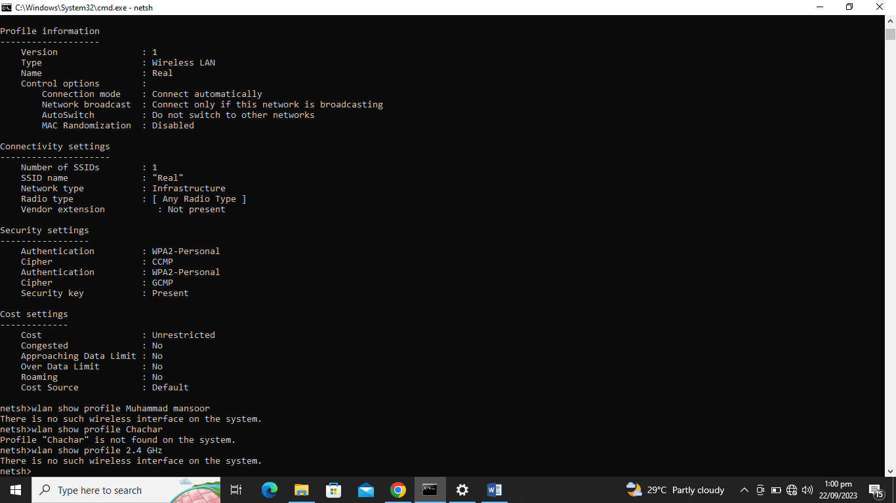

junaidsheikh02

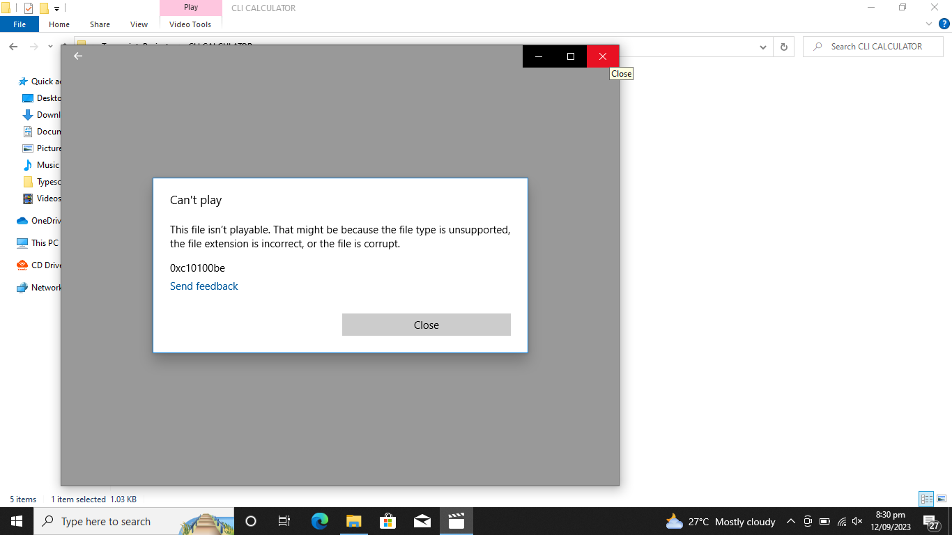

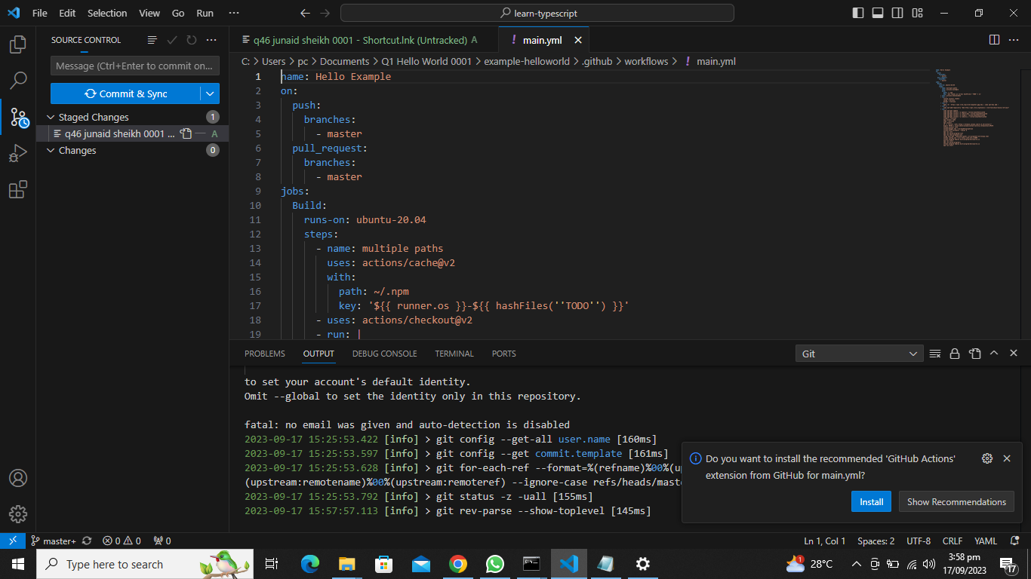

Welcome to CLI Calculator!

Please enter an expression (e.g., 2 + 3): 5 * 4

Result: 20

Do you want to perform another calculation? (yes/no): yes

Please enter an expression: 10 / 0

Error: Division by zero.

Do you want to perform another calculation? (yes/no): yes

Please enter an expression: 7 ^ 2

Error: Invalid operator.

Do you want to perform another calculation? (yes/no): no

Goodbye!



NODE_PROJECTS/project00_calculator

NODE_PROJECTS/project00_calculator

